Chapter 4, Problem 62.

Find the Thevenin equivalent of the circuit in Fig. 4.128.

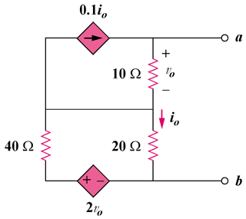

Figure 4.128
For Prob. 4.62.

